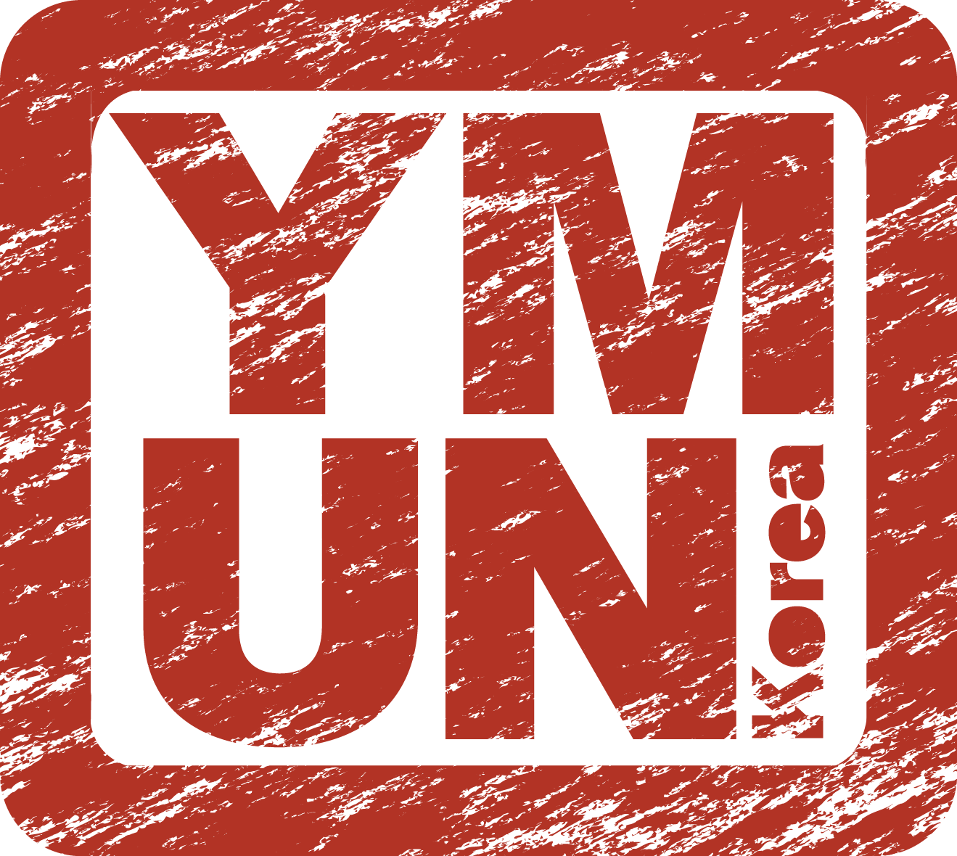
ACCOMMODATION REQUEST FORM AND RELEASE OF LIABILITY

The Yale Model United Nations Korea Secretariat will be arranging accommodation for interested delegates through our host venue the Seoul Olympic Parktel. Delegates will be assigned accommodation with up to three other delegates of the same gender per room and charged accordingly. If delegates wish to have a private room for an extra charge, please contact ymunkorea.international@yira.org. Accommodation through Yale Model United Nations Korea is not required and may be arranged independently.

Payment is available through domestic account transfer or international wire transfer to the following bank account. The delegate is responsible for any transaction fees incurred by the international wire transfer. Accommodation during the conference (Check-in May 19th, 2017 / Check-out May 21st, 2017) is $60 or 66,000 won. For beyond the duration of the conference, rates may vary. For more information on extended accommodation, please contact ymunkorea.international@yira.org.

Account Name: YOOJIN HAN
Account Number: 110-468-536513
Bank Name: SHINHAN BANK
Bank Address: 120, 2-GA TAEPYUNG-RO, CHUNG-GU, SEOUL, SOUTH KOREA
Swift Code: SHBKKRSE

Account Name: 한유진
Account Number: 110-468-536513
Bank Name: 신한은행

- Accommodation Information: Seoul Olympic Parktel

Accommodation Request Forms and payment are due April 19th, 2017. Forms submitted after April 19th are not guaranteed to be processed.
The last day to request for cancellations and refunds is April 19th, 5PM, Korea Standard Time, and no refunds will be issued for any requests submitted afterwards. Requests for refunds must be submitted to ymunkorea.international@yira.org.

Name
Country
Tel / Fax | Telephone |  |  | Fax
E-mail
Check-in | (MM/DD/YY) |  |  | Check-out | (MM/DD/YY)

- Additional Information
  - Does the delegate have any allergies/dietary restrictions?

  - Does the delegate have any medical conditions which should be brought to the attention of the YMUNK Secretariat?

  - Is there anyone with whom this delegate wishes to request accommodation? Note that while the secretariat will make all efforts to assign delegates to room with other delegates who they request, delegates are not guaranteed their requested roommates.
- Release of Liability

Before you sign this Agreement, please read it carefully because it affects your legal rights.
Assumption of Risk, Release from Liability and Indemnification

My child, ________________________________________ [Name of Delegate], will participate in the Yale Model United Nations Korea 2017 (the “Program”) from May 19th to 21st, 2017, which is being organized and run by the Yale International Relations Association, a registered undergraduate student organization of Yale University. This document (“Agreement”) covers all aspects of my child’s participation in the Program. In this Agreement, “Yale” refers to Yale University, its trustees, officers, employees, trainees, appointees, students, volunteers, and agents and the Yale International Relations Association (“YIRA”).

My child, ________________________________________ [Name of Delegate], will also be arranging accommodation from __________________________ [Check-in Date] to __________________________ [Check-out Date] at the Seoul Olympic Parktel (the “Venue”) through the Program. This document covers all aspects of requesting accommodation arranged through the Program at the Venue.

- Release of Liability. By registering for the Yale Model United Nations Korea 2017 conference, the undersigned hereby waives all legal rights to bring a lawsuit against Yale. Waiver of all claims shall include any and all claims for damages for either personal injury or financial losses. No additional rights or claims shall arise from the representations made by any of the administration, Yale students, Yale employees, or their representatives. Students may be expelled from the Program for misconduct whether proven or alleged. No additional claims shall arise if a student is expelled from the Program with or without cause. In order to attend the Program, this waiver must be signed by both parents and the student. Any disputes shall be decided by the Yale Model United Nations Korea Secretariat in accordance with the Terms and Conditions, which is available online. By attending the Program, both student and parent recognize that no remedies of action exist in either Korean or United States courts against the organizers of sponsors of the Program as these claims are all waived by signing this liability.
- Program Risks. I understand that participation in the Program involves risks that Yale cannot eliminate, including but not limited to, risk of property damage, illness, accidents from unaccompanied domestic or international travel to and from the conference, bodily injury, permanent disability, and other risks or accidents which may occur involving the Program. I understand that no claims shall arise against the Program, YIRA, or the Venue as a result of these risks.
- Venue Risks. I understand that the Program is not held responsible for any accidents which may occur at the Venue or for the quality of the services and facilities provided by the Venue. The Venue is a private entity and no claims shall arise in the event of an accident incurred at the Venue.
Printed Name of Parent/Legal Guardian: ___________________________________________________________________

Signature of Parent/Legal Guardian: _______________________________________________Date:___________________

Printed Name of Child: ___________________________________________________________________________________

Signature of Child: _______________________________________________________________Date:___________________

